Create a Model class-Employee

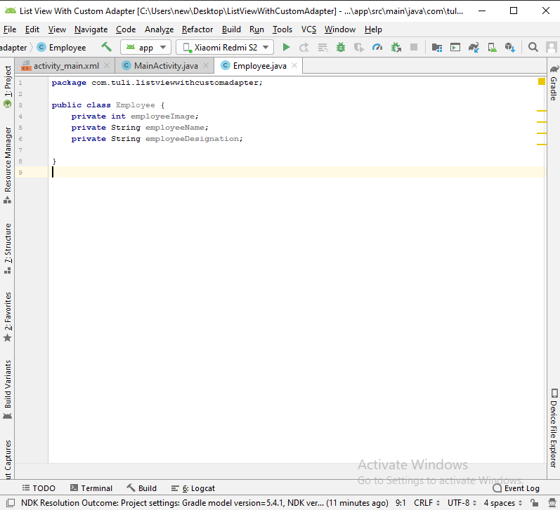

Constructor, getter setter call

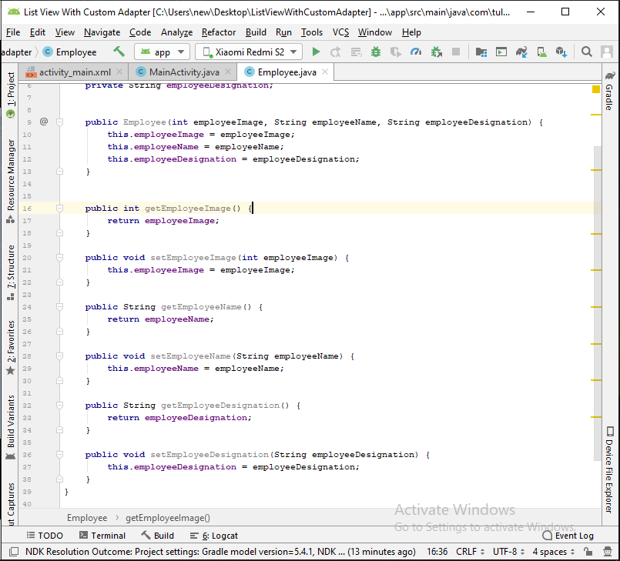

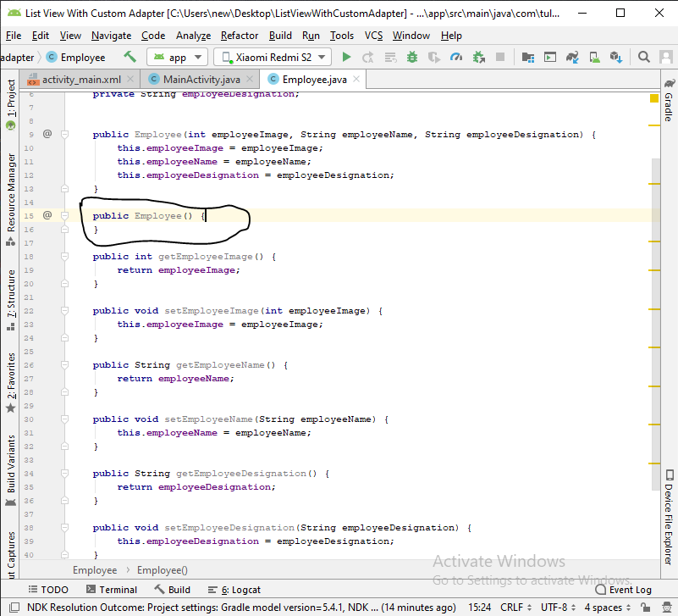

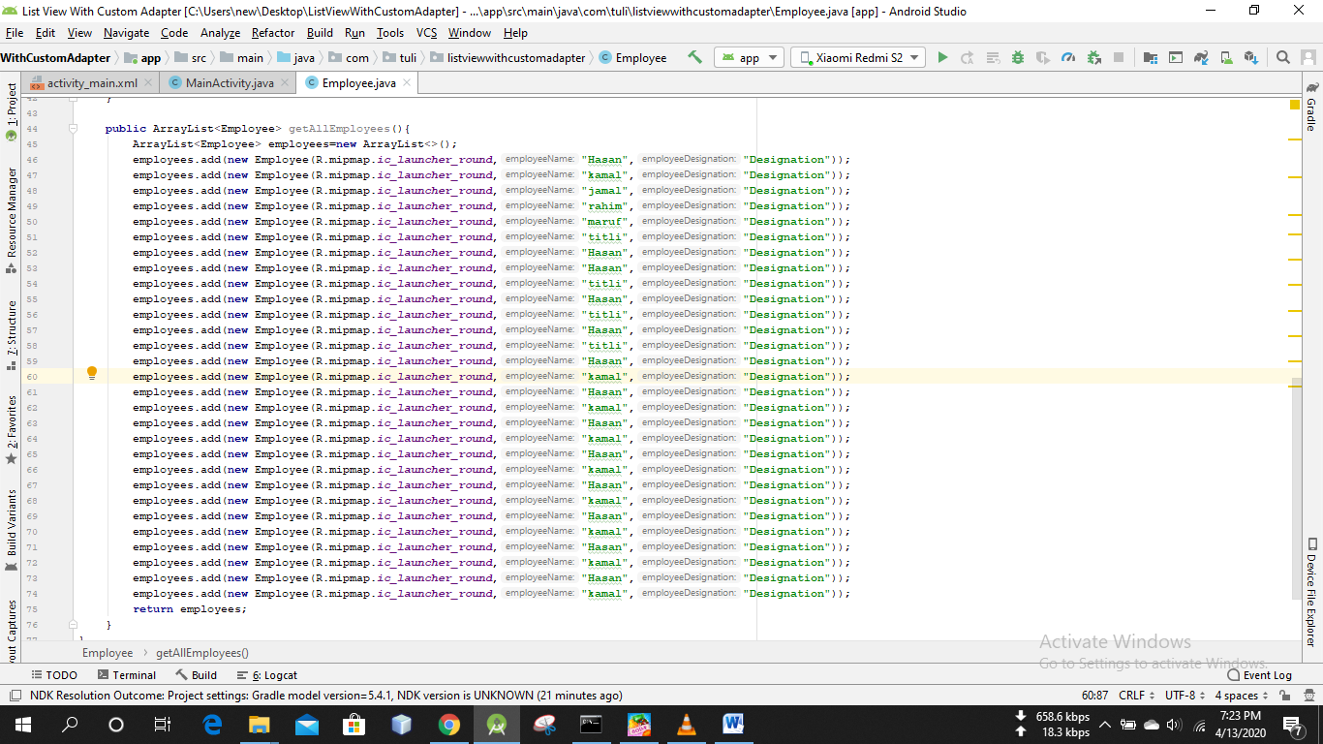

Layout-new-layout resource file-employee_single_row

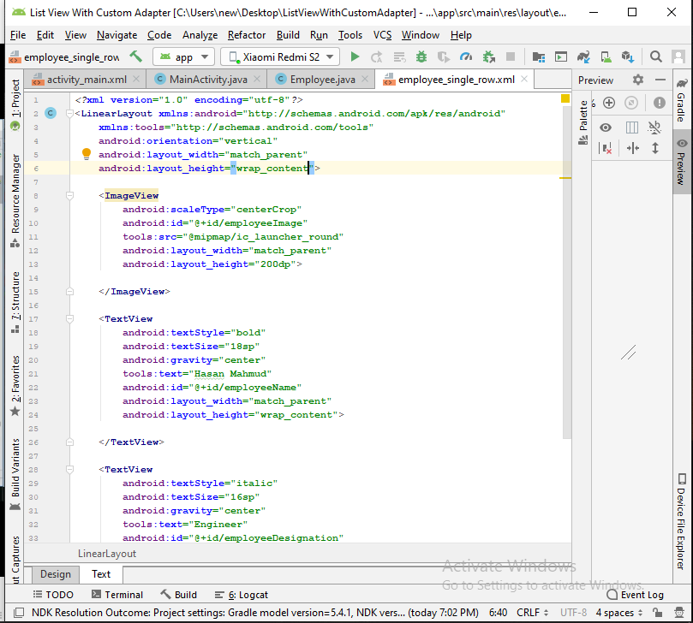

*<?***xml version="1.0" encoding="utf-8"***?>*<**LinearLayout xmlns:android="http://schemas.android.com/apk/res/android"  
 xmlns:tools="http://schemas.android.com/tools"  
 android:orientation="vertical"  
 android:layout_width="match_parent"  
 android:layout_height="wrap_content"**>  
  
 <**ImageView  
 android:scaleType="centerCrop"  
 android:id="@+id/employeeImage"  
 tools:src="@mipmap/ic_launcher_round"  
 android:layout_width="match_parent"  
 android:layout_height="200dp"**>  
  
 </**ImageView**>  
  
 <**TextView  
 android:textStyle="bold"  
 android:textSize="18sp"  
 android:gravity="center"  
 tools:text="Hasan Mahmud"  
 android:id="@+id/employeeName"  
 android:layout_width="match_parent"  
 android:layout_height="wrap_content"**>  
  
 </**TextView**>  
  
 <**TextView  
 android:textStyle="italic"  
 android:textSize="16sp"  
 android:gravity="center"  
 tools:text="Engineer"  
 android:id="@+id/employeeDesignation"  
 android:layout_width="match_parent"  
 android:layout_height="wrap_content"**>  
  
 </**TextView**>  
</**LinearLayout**>

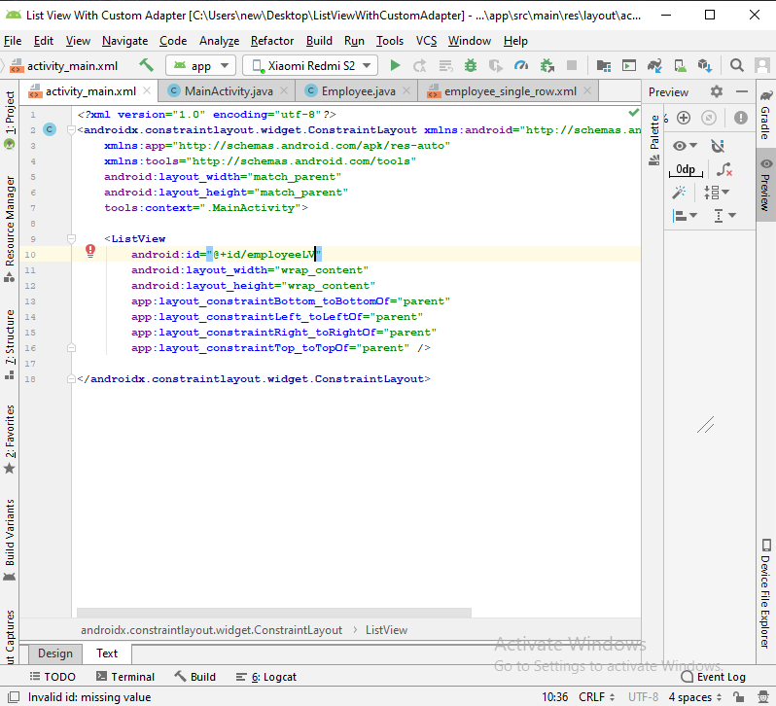

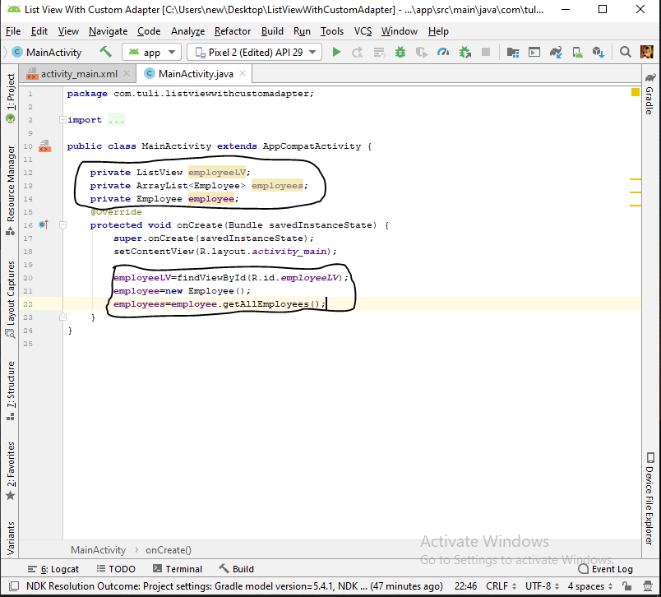

Create new class- EmployeeAdapter

